W05 Lesson: Financial Stewardship
W05 Lesson: Financial Stewardship

The Self-Reliance Approach versus a Common Approach to Finances
The Common Approach
The most common approach to finances looks something like the following:
- We receive money.
- We pay for our current needs and wants.
- We pay tithing or save a little, but only if we have money left over.
The Self-Reliant Approach
The Gospel of Jesus Christ teaches us that there is a better, more self-reliant approach to financial stewardship:
- We receive money.
- We pay the Lord first.
- We pay for the future.
- Then we pay for our current needs and wants.
Consider how the self-reliant approach prioritizes how you use the financial resources given to you from Heavenly Father. Paying current living expenses may seem more important, but neglecting the other elements can come at a long-term cost.
Paying tithes and offerings, for example, may result in a temporary loss of money, but it comes with a promise of many blessings. President Dallin H. Oaks of the First Presidency has said, “The payment of tithing is a test of priorities” (Tithing, Ensign, May 1994). Heber J. Grant has taught, “[To] the men and the women who have been absolutely honest with God [and] who have paid their tithing, God has given the wisdom whereby they have been able to utilize the remaining nine-tenths, and it has been of greater value to them, and they have accomplished more with it than they would if they had not been honest with the Lord” (Personal Finances for Self-Reliance, 2017).

Financial Stewardship Success
The following principles can help you have financial stewardship success. These principles are from the Self-Reliance manual called Personal Finances for Self-Reliance.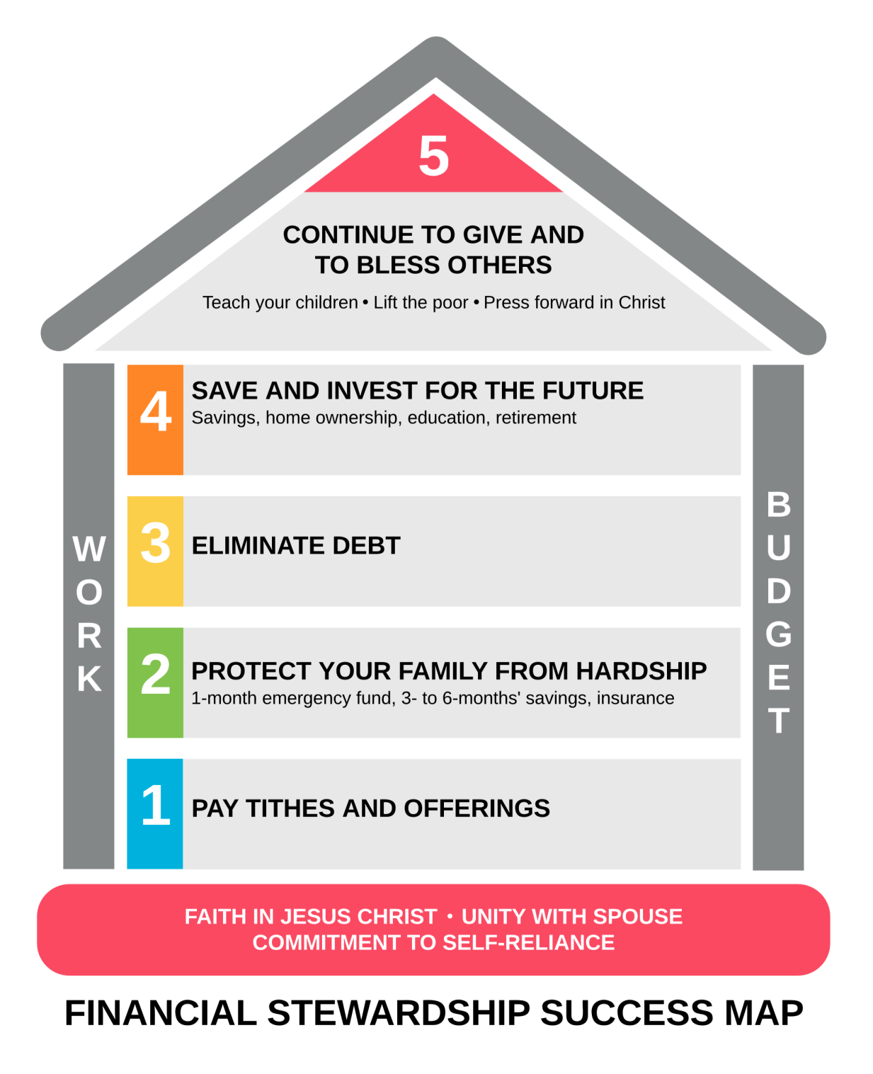
Following the principles on this map will help you manage your finances in a way that can help you find great peace. This lesson has already discussed paying tithes and offerings. The rest of the lesson will give you some helpful information on the other steps.

Protect Yourself from Financial Hardship
In the Old Testament, we learn that Joseph warned Pharaoh of the seven years of plenty that would happen before the seven years of famine. Pharaoh could have ignored Joseph’s warning, but instead chose to take his advice by storing up as much grain as possible. He and his people would then have a storage of wheat during the years of famine. This simple step of slowly building up a supply of wheat literally saved his entire kingdom.
Like this example, your financial stewardship imposes upon you the responsibility to take certain steps during years of plenty to protect you and your family from financial hardship when it comes your way.
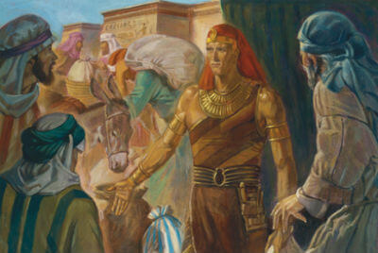

Create an Emergency Fund
Hard times are sure to come. Some may be of your own making, but often they come because it’s just the nature of this fallen world. As Adam and Eve were warned before leaving the Garden of Eden, we should remember that “Cursed shall be the ground for thy sake…thorns and thistles shall [the earth] bring forth unto thee…[and] by the sweat of thy brow shalt thou eat bread, until thou shalt return unto the ground” (Moses 4:23–25).
Because you cannot predict when your own personal thorns and thistles might appear, it is crucial that you begin today to prepare for them. An emergency fund is one such way to do that.
Financial advisors generally urge people to put away the financial equivalent of 3–6 months worth of total living costs for emergency situations. While such a reserve is definitely the end-goal, starting small with a one-month reserve is a great start.
Check My Understanding
Answer these questions to see what you remember from reading the text above.
- In the self-reliant approach to finances, what is the first thing you do after receiving money? ANSWER
- What biblical story is cited as an example of preparing for financial hardship? ANSWER
- How much of a financial reserve is generally advised for emergency situations? ANSWER

Acquire Adequate Insurance
If you can, adding insurance can be another layer of protection for you and your family. Research these three types of insurance. Check if they are available to you.
- Health Insurance—this can provide you and your family protection from the heavy financial burden of medical expenses.
- Life and Disability Insurance—this can provide you and your family with protection from the financial burden of sudden death or loss of income due to disability.
- Property Insurance (Homeowners, Renters, and Automobile)—this can provide you and your family protection from the financial burden of damage to your automobile or to the property you own or rent.
Not all forms of insurance are the same. Careful prayer, study, and consideration should be given before acquiring its different forms. For more information on things such as common insurance vocabulary and guiding principles for selecting insurance coverage, feel free to review the entire chapter on Protecting Your Family from Hardship in the Personal Finances for Self-Reliance manual or talk with your local stake president about enrolling in your stake’s self-reliance Personal Finance course.

Eliminate Debt
Think about the following questions: How much debt do you have? What are the interest rates? How much do you owe and how long will it take you to pay it back? Knowing the answers to these basic questions is vitally important to your success in understanding your current debt reality. A simple way to gather and assess this information is to create something called a debt inventory chart like the one you see below:
 | Creditor | Balance | Minimum Payment | Actual Payment | Interest Rate
Debt 1 | Credit Card #1 | 4,000 | 97 | 97 | 17%
Debt 2 | Credit Card #2 | 6,500 | 168 | 168 | 19%
Debt 3 | Car | 5,000 | 145 | 145 | 3%
Debt 4 | Student Loan | 18,000 | 300 | 300 | 5.5%
Debt 5 | Mortgage | 170,000 | >1,050 | 1,050 | 4.5%
As the table above shows, a debt inventory helps you know all the important information about what you owe. If you have debt, make a debt inventory for yourself. It will help you see clearly the realities of debt and the ways it can delay the achievement of your desired financial goals.
The Personal Finance for Self-reliance handbook says, “We have been counseled to pay down our debts as quickly as we can. “If you incur debt…work to repay it as quickly as possible and free yourself from bondage” (True to the Faith, 2004). There are several ways this can be done, but most financial experts generally recommend that at least the following three actions be taken.
Action 1: Pay Extra Toward Your Debt
The longer you have a loan, the more interest you will pay. If you pay extra towards debt, you will save money on interest. Try it!
- Review the following link When will my loan be paid off?, to see how much interest you would pay on Debt-1 above if you made the minimum payment. (Because this calculator is on the internet, you can use a web browser to translate it if you wish.)
- Then calculate it again with 100 more added to the current monthly payment. What happened? The interest paid goes from 2,051 to 750. That's a big saving!
Action 2: Decide Where to Pay Extra
Look at the table below and prayerfully decide which option is best. Consider the advantages and disadvantages of both.
Method | Advantages | Disadvantages
Highest Interest First | Eliminates most expensive debts earlier. | Could take longer to reduce the number of creditors.  Delayed psychological wins.
Lowest Balance First | Reduces number of creditors more quickly.  Reduces number of minimum payments more quickly.  Provides quicker psychological wins. | Could be more expensive since you aren't paying off the debts with the highest interest first.
Action 3: Use the rollover method
In this method, once a debt is paid off, you apply the money you were paying to that debt to the next debt, and so on. Try this method by going through the following steps:
Step 1: Open the financial calculator (How soon could I pay off all my debts?). (Because this calculator is on the internet, you can use a web browser to translate it if you wish.)
Step 2: Enter the information below. Note how we are adding an extra 100 to the actual payment of Debt-1. Note that the total actual payment each month for all debts is 1,860.
 | Creditor | Balance | Minimum Payment | Actual Payment | Interest Rate
Debt 1 | Credit Card #1 | 4,000 | 97 | 197 | 17%
Debt 2 | Credit Card #2 | 6,500 | 168 | 168 | 19%
Debt 3 | Car | 5,000 | 145 | 145 | 3%
Debt 4 | Student Loan | 18,000 | 300 | 300 | 5.5%
Debt 5 | Mortgage | 170,000 | >1,050 | 1,050 | 4.5%
Step 3: Scroll down to the bottom of the financial calculator, adjust the debt ordering drop-down menu from the shortest to the longest payoff period and adjust your interest earned on savings to 0%. Then click Calculate. The results should look something like the information below. Note that when you use the Roll-Over payment plan, you save over $35,000!
Results
While keeping your payment level at $1,860 you could reduce your total debt payments (principal and interest) from $303,322 to $267,406 and be out of debt in 12.0 years instead of your current projected 20.9 years. This represents a reduction of $35,916 and 8.9 years. Further, once all debts have been paid off, you could invest the same monthly payment amount at 0.00% and accumulate a savings account balance $198,648 over that same time period.

Save and Invest for the Future
Once debt gets eliminated by the “rollover method,” the next logical step is to roll over those same payments that had been going toward paying off debt to investing in your future. As you save and invest, follow these three basic principles.
Principle 1: Save Money
One of the easiest and safest ways to invest your money and in your future is to put some away in a safe place such as a savings account. As Elder L. Tom Perry has taught, “[Consider] pay[ing] yourself a predetermined amount of money into savings…It is amazing to me that so many people work all of their lives for a grocer, the landlord, the power company, the automobile salesman, and the bank, and yet think so little of their own efforts that they pay themselves nothing” (“Becoming Self-Reliant,” Nov. 1991). Watch how Sedrick saved money against impossible odds: Sedrick's Journey (02:32 mins, "Sedrick's Journey" Transcript).
Principle 2: Seek Education
Another way you can invest in yourself and your future is by obtaining an education. You are already doing this by being enrolled in this PathwayConnect Program! In a talk called "A Prophet's Counsel and Prayer for Youth," delivered in January 2001, President Gordon B. Hinckley wisely taught, “The world will in large measure pay you what it thinks you are worth, and your worth will increase as you gain education and proficiency in your chosen field.”
Principle 3: Set a Retirement Goal
As you learned earlier in this lesson, investing is “putting time, effort, or money into something and expecting some type of a return” (Personal Finances for Self-Reliance, p. 184). One of the reasons you may want to invest is to create a way for you to eventually retire from work. While there may be government or social programs in your area to help support you during your retirement years, you will likely need to supplement those programs with some of your own savings in order to cover all of your expenses. Note in the image below how investing at different interest rates affects the balance. The longer you invest, the more you can make. If you can, start saving or investing now. Here is a calculator that can help you do some initial planning: How much should I save for retirement? (Because this calculator is on the internet, you can use a web browser to translate it if you wish.)
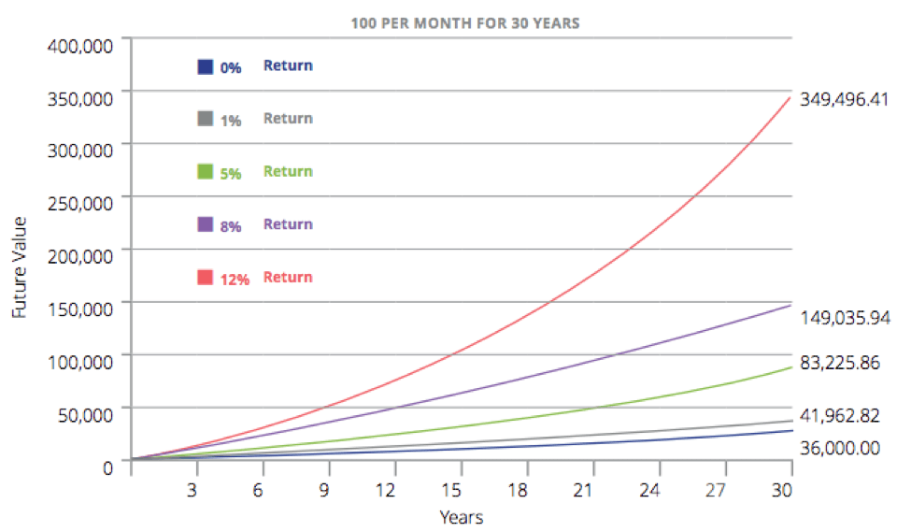
Disclaimer: The savings and investment content in this lesson is intended to be an introduction only, and not a replacement for professional financial advice specific to your circumstances. Examples are given for explanatory purposes only and are not to be interpreted as tax, legal, or investment advice.

Continue to Give and to Bless Others
After working hard to provide for yourself and your family, giving to and blessing the lives of others is a continual example of your faith and priorities. Blessings come to those who seek the Kingdom of God first (3 Nephi 13:33).
Check My Understanding
Answer these questions to see what you remember from reading the text above.
- What is a debt inventory? ANSWER
- What is the debt roll-over method? ANSWER
- What are the three basic principles advised for saving and investing for the future? ANSWER

Use a Budget
One of the pillars of the Financial Stewardship Success Map is a budget. A budget is essentially a plan. Using a budget, you plan how you will use your money for a certain period of time. Following a budget is freeing in that it will help you and your family take control of your temporal life, avoid many of the financial dangers of the world, and protect your family from potential hardship.
President N. Eldon Tanner once noted, “I am convinced that it is not the amount of money an individual earns that brings peace of mind as much as it is having control of his money. Money can be an obedient servant but a harsh taskmaster. Those who structure their standard of living to allow a little surplus, control their circumstances. Those who spend a little more than they earn are controlled by their circumstances. They are in bondage" (October 1979 General Conference). Do the following two things before you start building a budget:
- Figure out what your net income is. This is what you actually take home and can spend after things like taxes are taken out.
- Classify your expenses as either fixed or variable. Generally, fixed expenses don't change much from week to week or month to month. An example would be rent or a motorcycle payment. Variable expenses change. An example of this would be food purchases. You have much more control over variable expenses.

Balancing a Budget
Balancing a budget can sometimes be a difficult task. As you start to put your new budget together, you may find that you have more expenses than net income. If this is the case for you, know that you are not alone. Take heart and understand that this is a problem you can work through. There are essentially just two basic ways to fix this problem.
- Spend less money. This sounds simple, but it can be very difficult to achieve if you are not willing to change.
- Earn more income. In addition to cutting out useless spending, there is also the option of earning additional income. You are already on a great path toward this outcome. As you complete certificates and eventually degrees, you have very real potential to increase your income. It is important to remember, however, that career advancement takes time and considerable sacrifice. It seldom happens overnight. It is something to strive for along with your goals to spend less money.

Sticking to a Budget
Sticking to a budget can be difficult. As Elder Joseph B. Wirthlin has taught, “Those who live safely within their means know how much money comes in each month, and even though it’s difficult, they discipline themselves to spend less than that amount” (Earthly Debts, Heavenly Debts, Ensign, May 2004, 42). The rest of this section gives four principles that can help you stick to a budget.
Principle 1: Set Realistic Goals
It is no secret that goal-setting can be a powerful tool to help us maintain a healthy long-term perspective as well as get to desired destinations. As you look over the chart below and answer its accompanying questions, try to imagine what your own financial goals are for your future. Why are you setting them? What do you hope to achieve? What high, mid and lower-level goals might enable you to get where you want to be in terms of your financial stewardship?
Answer the questions below. The first question to which you answer no represents what should be your current financial priority.
- Do I pay tithing?
- Do I have a one-month emergency fund?
- Do I have health insurance or some other access to medical care?
- Am I free from consumer debt, like credit cards and car loans?
- Do I have a three- to six-month emergency fund?
- Am I contributing to a retirement savings fund?
- Am I working to eliminate mortgage and education loans?
Principle 2: Find and Use an Effective Budgeting System
You can use a spreadsheet like Microsoft Excel to create a budget. You will practice this in this week's Application Activity. There are also other methods you can try on your own, like the following two:
- Digital Systems. If you use a bank, the bank has digital records of your income and expenses. Many times, banks also have ways for you to categorize these elements so you can track these budget categories in real time.
- Envelope System. This approach to budgeting involves withdrawing a certain amount of money each pay-period to cover necessary expenses. No debit or credit cards can be used. You set and follow your budget by and paying for all needed items with the cash from that envelope. To learn more about the envelope system, please watch the video called The Envelope System (02:28 mins, "The Envelope System" Transcript).
Principle 3: Hold Yourself Accountable
Much of your success with goals and your budget is completely dependent on your ability to follow-up and follow-through. The best way to ensure appropriate follow-up is to council regularly with your family or on your own. Consider successes and failures and set goals about how those failures can be solved in the near future. Stay accountable!
Principle 4: Counsel with the Lord
Even as we desire to seek the will of the Lord and turn our financial stewardship over to Him and His purposes, it is important to remember that there will be a process of learning involved. You may sometimes make mistakes. Because you are being asked to change deep habits, you may find yourself making an unwise purchase despite your best attempts to stop. You may even find yourself on the receiving end of a financial crisis beyond your control, such as loss of employment or property.
Take your concerns to the Lord and pray for guidance and inspiration and then make adjustments to your budget and financial goals. As the Lord has promised, “[He] will go before your face. [He] will be on your right hand and your left, and [His] spirit shall be in your heart, and [His] angels round about, to bear you up” (D&C 84:88). He supports you in your financial stewardship and will do all He can to help you become who you are meant to be.
Check My Understanding
Answer these questions to see what you remember from reading the text above.
- What tool is described as a plan for how you will use your money for a certain period of time? ANSWER
- What are the two basic ways to fix a budget deficit where expenses exceed net income? ANSWER
- What method involves withdrawing cash each pay period to cover necessary expenses, with no debit or credit cards allowed? ANSWER

W05 Gathering Prep
What will you do this week, in preparation for the gathering, to exemplify the Learning Model principle of “Teach One Another?” If you are confident with the math content up to this point, offer to help someone in your gathering group this week. If you do not understand something, ask questions at your gathering. Don’t be afraid to speak up.
Ponder and Record
After reading this lesson, ponder the following questions. If desired, record your thoughts in a learning journal.
- What are the core differences between the Common Approach and the Self-Reliant Approach?
- Why should payment of tithes and offerings take priority over the payment of living expenses?
- How does the self-reliant approach to budgeting help you to become a better steward over your finances?
- What is the state of your current budget? Are you spending more than your net income? In what areas could you decrease spending?

PC 101 W05 Lección: Administración financiera

El enfoque de autosuficiencia versus un enfoque común de las finanzas
El enfoque común
El enfoque más común hacia las finanzas se parece al siguiente:
- Recibimos dinero.
- Pagamos por nuestras necesidades y deseos actuales.
- Pagamos el diezmo o ahorramos un poco, pero sólo si nos sobra dinero.
El enfoque autosuficiente
El Evangelio de Jesucristo nos enseña que existe un enfoque mejor y más autosuficiente para la administración financiera:
- Recibimos dinero.
- Pagamos al Señor primero.
- Pagamos por el futuro.
- Luego pagamos por nuestras necesidades y deseos actuales.
Considere cómo el enfoque de autosuficiencia prioriza cómo utiliza los recursos financieros que le dio nuestro Padre Celestial. Pagar los gastos de vida actuales puede parecer más importante, pero descuidar los demás elementos puede tener un costo a largo plazo.
Pagar los diezmos y las ofrendas, por ejemplo, puede resultar en una pérdida temporal de dinero, pero viene con la promesa de muchas bendiciones. El presidente Dallin H. Oaks, de la Primera Presidencia, dijo: “El pago del diezmo es una prueba de prioridades” ( Diezmo, Liahona, mayo de 1994 ). Heber J. Grant enseñó : “[A] los hombres y mujeres que han sido absolutamente honestos con Dios [y] que han pagado sus diezmos, Dios les ha dado la sabiduría mediante la cual han podido utilizar las nueve décimas partes restantes, y ha sido de mayor valor para ellos, y han logrado más con él de lo que lograrían si no hubieran sido honestos con el Señor” ( Finanzas personales para la autosuficiencia , 2017 ).

Éxito en la administración financiera
Los siguientes principios pueden ayudarle a tener éxito en la administración financiera. Estos principios provienen del manual de Autosuficiencia " Finanzas Personales para la Autosuficiencia" .
Seguir los principios de este mapa te ayudará a administrar tus finanzas para encontrar paz. Esta lección ya ha abordado el pago de diezmos y ofrendas. El resto de la lección te brindará información útil sobre los demás pasos.

Protéjase de las dificultades financieras
En el Antiguo Testamento, aprendemos que José advirtió al faraón sobre los siete años de abundancia que vendrían antes de los siete años de hambruna. El faraón podría haber ignorado la advertencia de José, pero en cambio optó por seguir su consejo y almacenar la mayor cantidad de grano posible. Él y su pueblo tendrían entonces reservas de trigo durante los años de hambruna. Esta simple medida de acumular poco a poco un suministro de trigo literalmente salvó todo su reino.
Al igual que este ejemplo, su administración financiera le impone la responsabilidad de tomar ciertas medidas durante los años de abundancia para protegerse a usted y a su familia de dificultades financieras cuando se presenten.

Crear un fondo de emergencia
Seguramente vendrán tiempos difíciles. Algunos pueden ser provocados por ti mismo, pero a menudo llegan porque es la naturaleza misma de este mundo caído. Como se les advirtió a Adán y Eva antes de salir del Jardín del Edén, debemos recordar que «Maldita será la tierra por tu causa… espinos y cardos te producirá [la tierra]… [y] con el sudor de tu frente comerás el pan hasta que vuelvas a la tierra» ( Moisés 4:23-25 ).
Como no puedes predecir cuándo aparecerán tus propios problemas, es crucial que empieces hoy mismo a prepararte para ellos. Un fondo de emergencia es una forma de hacerlo.
Los asesores financieros suelen recomendar a las personas reservar el equivalente a entre 3 y 6 meses de gastos de vida para emergencias. Si bien esta reserva es sin duda el objetivo final, empezar con una reserva de un mes es un excelente comienzo.
Comprueba mi comprensión
Responda estas preguntas para ver qué recuerda de la lectura del texto anterior.
- En el enfoque autosuficiente de las finanzas, ¿qué es lo primero que hace después de recibir dinero?RESPUESTA
- ¿Qué historia bíblica se cita como ejemplo de preparación para las dificultades financieras?RESPUESTA
- ¿Cuánta reserva financiera se aconseja generalmente tener para situaciones de emergencia?RESPUESTA

Adquirir un seguro adecuado
Si puede, añadir un seguro puede ser una capa adicional de protección para usted y su familia. Investigue estos tres tipos de seguro. Compruebe si están disponibles para usted.
- Seguro de salud : puede brindarle a usted y a su familia protección contra la pesada carga financiera de los gastos médicos.
- Seguro de vida e discapacidad : puede brindarle a usted y a su familia protección contra la carga financiera de una muerte repentina o pérdida de ingresos debido a una discapacidad.
- Seguro de propiedad (propietarios, inquilinos y automóviles) : esto puede brindarle a usted y a su familia protección contra la carga financiera de los daños a su automóvil o a la propiedad que posee o alquila.
No todos los seguros son iguales. Se recomienda orar, estudiar y considerar cuidadosamente antes de adquirir sus diferentes tipos. Para obtener más información sobre temas como el vocabulario común de seguros y los principios rectores para seleccionar una cobertura, consulte el capítulo completo sobre cómo proteger a su familia de las dificultades en el manual Finanzas Personales para la Autosuficiencia o hable con su presidente de estaca local sobre la posibilidad de inscribirse en el curso de Finanzas Personales para la Autosuficiencia de su estaca .

Eliminar la deuda
Piense en las siguientes preguntas: ¿Cuánta deuda tiene? ¿Cuáles son las tasas de interés? ¿Cuánto debe y cuánto tardará en pagarlo? Conocer las respuestas a estas preguntas básicas es fundamental para comprender su situación actual de deuda. Una forma sencilla de recopilar y evaluar esta información es crear un cuadro de inventario de deuda como el que se muestra a continuación:
 | Acreedor | Balance | Pago mínimo | Pago real | Tasa de interés
Deuda 1 | Tarjeta de crédito n.° 1 | 4.000 | 97 | 97 | 17%
Deuda 2 | Tarjeta de crédito #2 | 6.500 | 168 | 168 | 19%
Deuda 3 | Auto | 5.000 | 145 | 145 | 3%
Deuda 4 | Préstamo estudiantil | 18.000 | 300 | 300 | 5,5%
Deuda 5 | Hipoteca | 170.000 | >1.050 | 1.050 | 4,5%
Como muestra la tabla anterior, un inventario de deudas le ayuda a conocer toda la información importante sobre sus deudas. Si tiene deudas, haga un inventario de deudas. Esto le ayudará a ver claramente la realidad de las deudas y cómo pueden retrasar el logro de sus objetivos financieros.
El manual de Finanzas Personales para la Autosuficiencia dice: «Se nos ha aconsejado saldar nuestras deudas lo antes posible. Si contraes deudas… esfuérzate por saldarlas lo antes posible y liberarte de ellas» ( Fiel a la Fe, 2004 ). Hay varias maneras de hacerlo, pero la mayoría de los expertos financieros suelen recomendar al menos las tres siguientes medidas.
Acción 1: Pague extra de su deuda
Cuanto más tiempo tengas un préstamo, más intereses pagarás. Si pagas más por la deuda, ahorrarás dinero en intereses. ¡Pruébalo!
- Consulta el siguiente enlace " ¿Cuándo se pagará mi préstamo?" para ver cuánto interés pagarías por la Deuda-1 si hicieras el pago mínimo. (Como esta calculadora está en internet, puedes usar un navegador web para traducirla si lo deseas).
- Luego, vuelve a calcularlo añadiendo 100 más al pago mensual actual. ¿Qué pasó? El interés pagado pasa de 2051 a 750. ¡Un gran ahorro!
Acción 2: Decide dónde pagar extra
Observa la tabla a continuación y, con oración, decide cuál es la mejor opción. Considera las ventajas y desventajas de ambas.
Método | Ventajas | Desventajas
El interés más alto primero | Elimina las deudas más caras de forma anticipada. | Podría tomar más tiempo reducir el número de acreedores.  Victorias psicológicas retrasadas.
Saldo más bajo primero | Reduce más rápidamente el número de acreedores.  Reduce el número de pagos mínimos más rápidamente.  Proporciona victorias psicológicas más rápidas. | Podría ser más costoso ya que no estás pagando primero las deudas con el interés más alto.
Acción 3: Utilizar el método de rollover
Con este método, una vez saldada una deuda, se aplica el dinero que se pagaba a la siguiente, y así sucesivamente. Pruebe este método siguiendo estos pasos:
Paso 1: Abre la calculadora financiera (¿ Cuánto tiempo tardaré en pagar todas mis deudas? ). (Como esta calculadora está en internet, puedes usar un navegador web para traducirla si lo deseas).
Paso 2: Ingrese la información a continuación. Observe cómo añadimos 100 adicionales al pago real de la Deuda-1. Tenga en cuenta que el pago total mensual de todas las deudas es de 1860.
 | Acreedor | Balance | Pago mínimo | Pago real | Tasa de interés
Deuda 1 | Tarjeta de crédito n.° 1 | 4.000 | 97 | 197 | 17%
Deuda 2 | Tarjeta de crédito #2 | 6.500 | 168 | 168 | 19%
Deuda 3 | Auto | 5.000 | 145 | 145 | 3%
Deuda 4 | Préstamo estudiantil | 18.000 | 300 | 300 | 5,5%
Deuda 5 | Hipoteca | 170.000 | >1.050 | 1.050 | 4,5%
Paso 3: Desplázate hasta la parte inferior de la calculadora financiera, ajusta el orden de la deuda en el menú desplegable, del plazo de pago más corto al más largo, y ajusta el interés de tus ahorros al 0 %. Luego, haz clic en "Calcular". Los resultados deberían ser similares a la información a continuación. Ten en cuenta que al usar el plan de pagos con renovación, ¡ahorras más de $35,000!
Resultados
Manteniendo su nivel de pago en $1,860, podría reducir sus pagos totales de deuda (capital e intereses) de $303,322 a $267,406 y quedar libre de deudas en 12 años, en lugar de los 20.9 años proyectados actualmente. Esto representa una reducción de $35,916 y 8.9 años. Además, una vez saldadas todas las deudas, podría invertir el mismo monto de pago mensual al 0.00% y acumular un saldo de $198,648 en su cuenta de ahorros durante ese mismo período.

Ahorre e invierta para el futuro
Una vez que se elimina la deuda mediante el método de renovación, el siguiente paso lógico es renovar los pagos que se destinaban al pago de la deuda para invertir en el futuro. Al ahorrar e invertir, siga estos tres principios básicos.
Principio 1: Ahorrar dinero
Una de las maneras más fáciles y seguras de invertir su dinero y su futuro es guardar una parte en un lugar seguro, como una cuenta de ahorros. Como enseñó el élder L. Tom Perry: “Considere ahorrar una cantidad predeterminada… Me sorprende que tanta gente trabaje toda su vida para un tendero, el casero, la compañía eléctrica, el vendedor de autos y el banco, y sin embargo, valore tan poco sus propios esfuerzos que no se pague nada” ( “Cómo ser autosuficiente”, noviembre de 1991 ). Vea cómo Sedrick ahorró dinero contra todo pronóstico: La aventura de Sedrick (2:32 min, transcripción de " La aventura de Sedrick" ).
Principio 2: Buscar la educación
Otra manera de invertir en ti mismo y en tu futuro es obtener una educación. ¡Ya lo estás haciendo al inscribirte en este Programa PathwayConnect! En un discurso titulado "El consejo y la oración de un profeta por la juventud", pronunciado en enero de 2001, el presidente Gordon B. Hinckley enseñó sabiamente: "El mundo, en gran medida, te pagará lo que considere que vales, y tu valor aumentará a medida que adquieras educación y competencia en el campo que hayas elegido".
Principio 3: Establecer una meta de jubilación
Como aprendiste antes en esta lección, invertir es “dedicar tiempo, esfuerzo o dinero a algo y esperar algún tipo de rendimiento” (Finanzas Personales para la Autosuficiencia, pág. 184). Una de las razones por las que podrías querer invertir es para crear un plan que te permita jubilarte. Si bien puede haber programas gubernamentales o sociales en tu zona que te ayuden durante tus años de jubilación, probablemente necesites complementarlos con algunos de tus propios ahorros para cubrir todos tus gastos. Observa en la imagen de abajo cómo la inversión a diferentes tasas de interés afecta el saldo. Cuanto más tiempo inviertas, más podrás ganar. Si puedes, empieza a ahorrar o invertir ahora. Aquí tienes una calculadora que puede ayudarte a planificar: ¿ Cuánto debería ahorrar para la jubilación? (Como esta calculadora está en internet, puedes usar un navegador web para traducirla si lo deseas).
Aviso legal: El contenido sobre ahorro e inversión de esta lección es solo una introducción y no sustituye el asesoramiento financiero profesional específico para sus circunstancias. Los ejemplos se ofrecen únicamente con fines explicativos y no deben interpretarse como asesoramiento fiscal, legal o de inversión.

Continúe dando y bendiciendo a los demás
Después de trabajar arduamente para proveer para sí mismo y su familia, dar y bendecir la vida de los demás es un ejemplo continuo de su fe y prioridades. Las bendiciones llegan a quienes buscan primero el Reino de Dios ( 3 Nefi 13:33 ).
Comprueba mi comprensión
Responda estas preguntas para ver qué recuerda de la lectura del texto anterior.
- ¿Qué es un inventario de deuda?RESPUESTA
- ¿Qué es el método de renovación de deuda?RESPUESTA
- ¿Cuáles son los tres principios básicos aconsejados para ahorrar e invertir para el futuro?RESPUESTA

Utilice un presupuesto
Uno de los pilares del Mapa del Éxito de la Administración Financiera es un presupuesto. Un presupuesto es, en esencia, un plan. Con un presupuesto, usted planifica cómo usará su dinero durante un período determinado. Seguir un presupuesto es liberador, ya que le ayudará a usted y a su familia a tomar el control de su vida temporal, evitar muchos de los peligros financieros del mundo y proteger a su familia de posibles dificultades.
El presidente N. Eldon Tanner comentó: «Estoy convencido de que no es la cantidad de dinero que gana una persona lo que brinda paz mental, sino más bien el control de su dinero. El dinero puede ser un siervo obediente, pero un amo severo. Quienes estructuran su nivel de vida para permitirse un pequeño excedente controlan sus circunstancias. Quienes gastan un poco más de lo que ganan están controlados por sus circunstancias. Están en cautiverio» (Conferencia General de octubre de 1979). Haga lo siguiente antes de comenzar a elaborar un presupuesto:
- Calcula tus ingresos netos. Esto es lo que realmente llevas a casa y lo que puedes gastar después de descontar impuestos, por ejemplo.
- Clasifica tus gastos como fijos o variables. Generalmente, los gastos fijos no cambian mucho de una semana a otra ni de un mes a otro. Un ejemplo sería el alquiler o el pago de una motocicleta. Los gastos variables cambian. Un ejemplo de esto sería la compra de alimentos. Tienes mucho más control sobre los gastos variables.

Equilibrar un presupuesto
Equilibrar un presupuesto a veces puede ser una tarea difícil. Al empezar a elaborar tu nuevo presupuesto, podrías descubrir que tienes más gastos que ingresos netos. Si este es tu caso, recuerda que no estás solo. Anímate y comprende que este es un problema que puedes solucionar. Básicamente, solo hay dos maneras de solucionarlo.
- Gastar menos dinero. Parece sencillo, pero puede ser muy difícil de lograr si no estás dispuesto a cambiar.
- Obtén más ingresos . Además de reducir gastos innecesarios, también existe la opción de obtener ingresos adicionales. Ya estás en el buen camino hacia este resultado. A medida que completas certificados y, eventualmente, títulos, tienes un gran potencial para aumentar tus ingresos. Sin embargo, es importante recordar que progresar profesionalmente requiere tiempo y un sacrificio considerable. Rara vez sucede de la noche a la mañana. Es algo que debes esforzarte, junto con tus objetivos de gastar menos dinero.

Cumplir con un presupuesto
Cumplir con un presupuesto puede ser difícil. Como enseñó el élder Joseph B. Wirthlin: “Quienes viven dentro de sus posibilidades saben cuánto dinero reciben cada mes, y aunque es difícil, se disciplinan para gastar menos de esa cantidad” ( Deudas terrenales, deudas celestiales, Liahona, mayo de 2004, pág. 42 ). El resto de esta sección presenta cuatro principios que pueden ayudarles a cumplir con un presupuesto.
Principio 1: Establecer metas realistas
No es ningún secreto que establecer metas puede ser una herramienta poderosa para ayudarnos a mantener una perspectiva saludable a largo plazo y alcanzar nuestros objetivos. Al revisar la tabla a continuación y responder a las preguntas que la acompañan, intente imaginar cuáles son sus propias metas financieras para el futuro. ¿Por qué las establece? ¿Qué espera lograr? ¿Qué metas de alto, medio y bajo nivel podrían permitirle alcanzar su meta en términos de administración financiera?
Responda las siguientes preguntas. La primera pregunta a la que responda "no" representa cuál debería ser su prioridad financiera actual.
- ¿Pago el diezmo?
- ¿Tengo un fondo de emergencia para un mes?
- ¿Tengo seguro médico o algún otro acceso a atención médica?
- ¿Estoy libre de deudas de consumo, como tarjetas de crédito y préstamos de automóviles?
- ¿Tengo un fondo de emergencia de tres a seis meses?
- ¿Estoy contribuyendo a un fondo de ahorro para la jubilación?
- ¿Estoy trabajando para eliminar préstamos hipotecarios y educativos?
Principio 2: Encuentra y usa un sistema de presupuesto eficaz.
Puedes usar una hoja de cálculo como Microsoft Excel para crear un presupuesto. Practicarás esto en la Actividad de Aplicación de esta semana. También existen otros métodos que puedes probar por tu cuenta, como los dos siguientes:
- Sistemas digitales. Si trabaja con un banco, este tiene registros digitales de sus ingresos y gastos. A menudo, los bancos también ofrecen formas de categorizar estos elementos para que pueda realizar un seguimiento de estas categorías presupuestarias en tiempo real.
- Sistema de Sobres. Este método de presupuesto implica retirar una cierta cantidad de dinero en cada nómina para cubrir los gastos necesarios. No se pueden usar tarjetas de débito ni crédito. Usted establece y controla su presupuesto pagando todos los artículos necesarios con el efectivo de ese sobre. Para obtener más información sobre el sistema de sobres, vea el video " El Sistema de Sobres " (2:28 min, Transcripción de " El Sistema de Sobres" ).
Principio 3: Hágase responsable
Gran parte de su éxito con las metas y su presupuesto depende completamente de su capacidad de seguimiento y cumplimiento. La mejor manera de garantizar un seguimiento adecuado es reunirse regularmente con su familia o por su cuenta. Considere los éxitos y los fracasos y establezca metas sobre cómo pueden solucionarse en el futuro cercano. ¡Sea responsable!
Principio 4: Consulta con el Señor
Aunque deseamos buscar la voluntad del Señor y confiarle nuestra administración financiera a Él y a sus propósitos, es importante recordar que implica un proceso de aprendizaje. A veces, puedes cometer errores. Debido a que se te pide cambiar hábitos arraigados, podrías encontrarte haciendo una compra imprudente a pesar de tus mejores esfuerzos por evitarlo. Incluso podrías encontrarte en medio de una crisis financiera que escapa a tu control, como la pérdida de tu empleo o de tu propiedad.
Lleva tus inquietudes al Señor y ora para recibir guía e inspiración, y luego ajusta tu presupuesto y tus metas financieras. Como el Señor ha prometido: “Él irá delante de tu faz. Estará a tu diestra y a tu siniestra, y su Espíritu estará en tu corazón, y sus ángeles alrededor para sostenerte” ( D. y C. 84:88 ). Él te apoya en tu administración financiera y hará todo lo posible para ayudarte a convertirte en quien estás destinado a ser.
Comprueba mi comprensión
Responda estas preguntas para ver qué recuerda de la lectura del texto anterior.
- ¿Qué herramienta se describe como un plan sobre cómo utilizará su dinero durante un período de tiempo determinado?RESPUESTA
- ¿Cuáles son las dos formas básicas de solucionar un déficit presupuestario cuando los gastos exceden los ingresos netos?RESPUESTA
- ¿Qué método implica retirar efectivo en cada período de pago para cubrir los gastos necesarios, sin permitir tarjetas de débito o crédito?RESPUESTA

W05 Preparación de la reunión
¿Qué harán esta semana, como preparación para la reunión, para ejemplificar el principio del Modelo de Aprendizaje de "Enseñarnos unos a otros"? Si se sienten cómodos con el contenido de matemáticas hasta este punto, ofrézcanse a ayudar a alguien de su grupo esta semana. Si no entienden algo, hagan preguntas en la reunión. No tengan miedo de expresarse.
Reflexionar y registrar
Después de leer esta lección, reflexiona sobre las siguientes preguntas. Si lo deseas, anota tus ideas en un diario de aprendizaje.
- ¿Cuáles son las diferencias fundamentales entre el Enfoque Común y el Enfoque Autosuficiente?
- ¿Por qué el pago de los diezmos y las ofrendas debe tener prioridad sobre el pago de los gastos de manutención?
- ¿Cómo el enfoque autosuficiente para elaborar un presupuesto le ayuda a convertirse en un mejor administrador de sus finanzas?
- ¿Cuál es el estado actual de su presupuesto? ¿Está gastando más de lo que gana? ¿En qué áreas podría reducir su gasto?

RESUMEN:
Pregunta (Español) | Question (English) | Respuesta
En el enfoque autosuficiente de las finanzas, ¿qué es lo primero que hace después de recibir dinero? | In the self-reliant approach to finances, what is the first thing you do after receiving money? | Pagar al Señor primero (Diezmos y ofrendas). / Pay the Lord first (Tithing and offerings).
¿Qué historia bíblica se cita como ejemplo de preparación para las dificultades financieras? | What biblical story is cited as an example of preparation for financial difficulties? | La historia de José, quien advirtió al faraón sobre los siete años de abundancia antes de la hambruna. / The story of Joseph, who warned Pharaoh about the seven years of plenty before the famine.
¿Cuánta reserva financiera se aconseja generalmente tener para situaciones de emergencia? | How much financial reserve is generally advised to have for emergencies? | Entre 3 y 6 meses de gastos de vida (aunque empezar con una reserva de un mes es un excelente comienzo). / Between 3 and 6 months of living expenses (although starting with a one-month reserve is an excellent start).

II. Comprueba mi comprensión (Deuda, Ahorro e Inversión)
Pregunta (Español) | Question (English) | Respuesta
¿Qué es un inventario de deuda? | What is a debt inventory? | Una forma sencilla de recopilar y evaluar la información importante sobre las deudas, como acreedor, saldo y tasa de interés. / A simple way to gather and evaluate important information about debts, such as creditor, balance, and interest rate.
¿Qué es el método de renovación de deuda? | What is the debt rollover method? | El método en el que, una vez saldada una deuda, el dinero que se pagaba se aplica a la siguiente deuda, y así sucesivamente, para acelerar la eliminación de la deuda. / The method where, once one debt is paid off, the money that was being paid is applied to the next debt, and so on, to accelerate debt elimination.
¿Cuáles son los tres principios básicos aconsejados para ahorrar e invertir para el futuro? | What are the three basic principles advised for saving and investing for the future? | 1. Ahorrar dinero; 2. Buscar la educación; 3. Establecer una meta de jubilación. / 1. Save money; 2. Seek education; 3. Establish a retirement goal.

III. Comprueba mi comprensión (Presupuesto)
Pregunta (Español) | Question (English) | Respuesta
¿Qué herramienta se describe como un plan sobre cómo utilizará su dinero durante un período de tiempo determinado? | What tool is described as a plan on how you will use your money over a specific period of time? | Un presupuesto. / A budget.
¿Cuáles son las dos formas básicas de solucionar un déficit presupuestario cuando los gastos exceden los ingresos netos? | What are the two basic ways to fix a budget shortfall when expenses exceed net income? | 1. Gastar menos dinero; 2. Obtener más ingresos. / 1. Spend less money; 2. Get more income.
¿Qué método implica retirar efectivo en cada período de pago para cubrir los gastos necesarios, sin permitir tarjetas de débito o crédito? | What method involves withdrawing cash on each pay period to cover necessary expenses, without allowing debit or credit cards? | El Sistema de Sobres. / The Envelope System.

Summary: Financial Stewardship and Self-Reliance
This lesson contrasts the Common Approach to finances with the Self-Reliant Approach taught by the Gospel of Jesus Christ, emphasizing that successful financial stewardship leads to peace and greater capability to serve.

I. The Self-Reliant Approach to Finances
The self-reliant approach prioritizes resource use based on divine principles, contrasting sharply with the common method of paying current needs first and saving only if money remains.
Self-Reliant Approach | Common Approach
1. We receive money. | 1. We receive money.
2. We pay the Lord first (Tithes & Offerings). | 2. We pay for current needs and wants.
3. We pay for the future (Savings & Debt). | 3. We pay tithing or save a little, but only if we have money left over.
4. Then we pay for our current needs and wants.
Paying tithes and offerings (paying the Lord first) is described as a "test of priorities" that promises blessings and greater wisdom in utilizing the remaining income.

II. Protecting Yourself from Financial Hardship
Financial stewardship requires proactive steps during times of plenty to prepare for inevitable hardship, exemplified by the biblical story of Joseph warning Pharaoh of the famine.
Create an Emergency Fund: It is crucial to prepare for unpredictable "thorns and thistles." Financial advisors generally recommend a reserve equal to 3–6 months of living costs, but starting with a one-month reserve is an excellent first step.
Acquire Adequate Insurance: Insurance provides another layer of protection. Key types to consider are Health, Life and Disability, and Property (Homeowners, Renters, and Automobile) insurance.

III. Eliminating Debt
Eliminating debt is vital, as debt can delay financial goals and lead to bondage (President N. Eldon Tanner).
Debt Inventory: The first step is to create a detailed chart to gather and assess all debt information (creditor, balance, interest rate).
Pay Extra: Paying more than the minimum saves money on interest and accelerates payoff.
Decide Where to Pay Extra: Choose between the Highest Interest First method (saves the most money, slower psychological wins) or the Lowest Balance First method (quicker psychological wins, potentially higher cost).
Use the Rollover Method: Once a debt is paid off, the money previously dedicated to that payment is "rolled over" and added to the payment of the next debt, drastically reducing the payoff time and total interest paid.

IV. Save and Invest for the Future
Once debt is eliminated, the funds from the rollover method should be channeled into future investment. The three basic principles are:
- Save Money: Pay yourself a predetermined amount into a savings account (Elder L. Tom Perry).

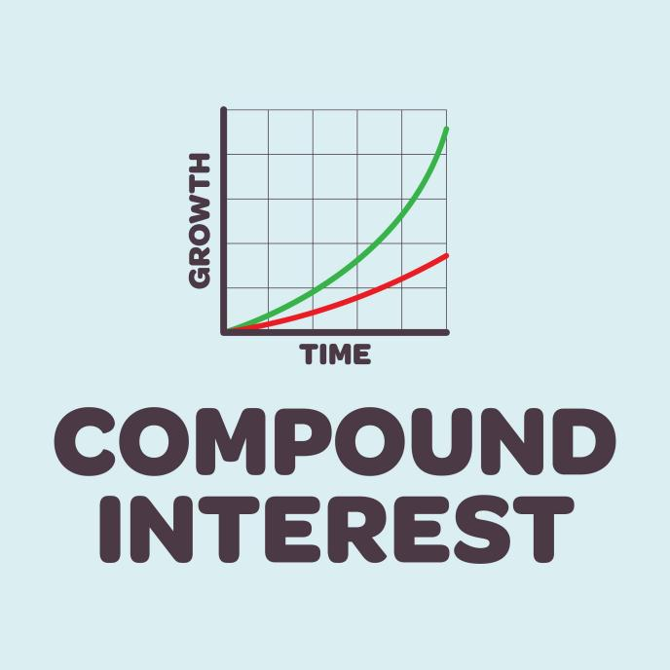
Shutterstock
- Seek Education: Increase your worth and proficiency, as the world will pay you what it thinks you are worth (President Gordon B. Hinckley).
- Set a Retirement Goal: Invest to supplement any government/social programs, as the longer you invest, the more you can earn.

V. Using and Sticking to a Budget
A budget is a plan for using money over a period, providing control over one's temporal life.
Preparation: Figure out your net income and classify expenses as fixed (e.g., rent) or variable (e.g., food).
Balancing: If expenses exceed net income, the two basic solutions are to spend less money or earn more income (recognizing career advancement takes time).
Sticking to It:
Set Realistic Goals.
Use an Effective Budgeting System (e.g., Digital Systems or the Envelope System, which uses cash withdrawn each pay period for expenses to enforce limits).
Hold Yourself Accountable by counseling regularly.
Counsel with the Lord, praying for guidance and inspiration when making adjustments or facing crises.

